What is a document library?

A document library provides a secure place to store files where you and your co-authors can find them easily, work on them together, and access them from any device at any time. For example, you can use a document library on a site in SharePoint Online to store all files related to a specific project or a specific client. Adding files or moving files between folders is as easy as dragging and dropping them from one location to another. Each document library displays a list of files, folders, and key information about each, such as who created or last modified a file. You can use this information to organize your files and make it easier to find them.

1. **saving storage space**

**To Prevent Having Multiple Versions of The Same File**

In the situation of sending a document as an attachment, the recipient of the mail can make changes to the file received and eventually become another version of the original files and sender can track such changes. But with the link, everyone gets to edit the same version of the file (original file), and sender can track all the changes and also restore versions easily thanks to [**versioning**](https://sharepointmaven.com/5-ways-users-can-benefit-versioning-sharepoint/) functionality if necessary.

**ABILITY TO VIEW AND MODIFY “IN THE BROWSER.”**

 With SharePoint links, the recipient does not need to have the latest version of MS Office installed on the machine due to [**Office Online capability**](https://sharepointmaven.com/office-online-sharepoint-onedrive/). Changes can be made right in the browser.

**Links helps to prevent recipients in Accessing Information Sent in Error:**

There has been situation where email with an attachment is sent in error, sometimes recall might not be possible. But when you sent a link through email in error, the links can be disable immediately or just remove the file as this will also disable the link as well.

Limited Access: item links are only available to recipients that have access to the SharePoint library, and have sufficient permissions to view the document/item while attachments in an email can be forward to other individuals.

Select one or more SharePoint items. Right-click and select one of the **Copy** commands. Paste the document, link, or address into the email message body.  
Use the **Copy** command menu to:

* Copy the **Document** file. *This option is only available for documents.*
* Copy a **Link** to the SharePoint item. This places the SharePoint item name with a hyperlink to its location on the Clipboard.
* Copy a **Link (Document ID)** to the SharePoint item. This option places the SharePoint item name with a hyperlink to its document ID on the Clipboard. This option is available if the library contains a Document ID property.
* Copy the **Address** of the SharePoint item. This places the URL of the SharePoint item on the Clipboard.

How do I view a document library in Windows explorer?

To open a SharePoint list in Windows Explorer:

1. Open the SharePoint site in Internet Explorer.
2. Navigate to the document you want to open in Windows Explorer.
3. Click the **Actions** menu (located near the top-right corner) to open the drop-down menu  and choose **Open with Windows Explorer**.
4. When prompted, enter your username and password
5. A Windows Explorer window will open, showing you the files in the list you have chosen

SCREENSHOT

**How can column headers in a document library be used to sort or filter the document library?**

SORT:

1. On top of the document library page, you’ll see a header that describes each column. Place your cursor over the column header by which you wish to sort the items. A drop-down arrow will appear to the right.

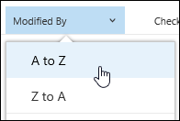

1. Click the arrow and select Ascending or Descending to sort the items accordingly.
2. Or simply click the header name and it will automatically sort them in ascending order. Click the header again and it will reverse them to descending order.

[Filter items in a document library](javascript:)

1. On top of the document library page, you’ll see a header that describes each column. Place your cursor over the column header by which you wish to filter the items. A drop-down arrow will appear to the right.
2. Click **Filter by** and then select the value that you want to use to filter the items in Filter by panel. Only items that match the value you've chosen will then show up in the list.

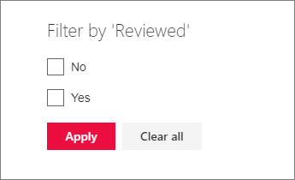

**How would you view only documents modified on a certain day**

1. Open the document Library that you want to view.
2. From the Settings menu, click create view.
3. On the View Type page, Choose a view format. If unsure, choose Standard View.
4. Add a **View Name** (there is an option of making it default view).
5. In the **Filter** section, click **Show items only when the following is true.**
6. Pick modified on the first drop-down field (The basis for the filter).
7. Pick “is equal to” in the second-drop down field.
8. Specify the day date on the next field using this **MM/DD/YYYY** format.
9. Click **OK**.

**How would you view only documents modified** **By a certain person?**

1. Open the document Library that you want to view.
2. From the Settings menu, click create view.
3. On the View Type page, Choose a view format. If unsure, choose Standard View.
4. Add a **View Name** (there is an option of making it default view)
5. In the **Filter** section, click **Show items only when the following is true**
6. Pick modified on the first drop-down field (The basis for the filter).
7. Pick “is equal to” in the second-drop down field.
8. In the third column, enter the individual’s name in a brackets (such as [Bunmi]).
9. Click **OK**.

**How do I add columns to the default view of a list?**

Columns help to categorize and track information, such as the department name or project number. You have several options for the type of column that you create, including a single line of text, a drop-down list of options, a number that is calculated from other columns, or even the name and picture of a person on your site.

1. Navigate to your list or library. If the name of your list or library does not appear, click View All Site Content, and then click the name of your list or library.
2. On the Settings menu, click Create Column. (If you cannot see this menu, you may not have the proper permissions).
3. In the Name and Type section, type the name that you want to appear as the Column name.
4. Under The type of information in this column is section, select the type of information that you want to appear in the column.
5. Type a description in the Description box to help people understand the purpose of the column and what data it should contain (this is optional).
6. Depending on the type of column that you selected, more options may appear in the Additional Column Settings section. Select the additional settings that you want.
7. To add the column to the default view—which people on your site automatically see when they first open a list or library—click Add to default view.
8. Click OK.

**What is a Gantt chart view of a task list?**

This provides a visual view of data, with bars that track progress (if your data is based on a time interval). A Gantt view can help you manage projects of all sizes and they are a useful way of showing what work is scheduled to be done on a specific day. You can also see a quick overview of your data. Use this view, for example, to see which tasks overlap and to visualize overall progress.

**How do I create a Gantt chart view for a single team member?**

1. Access the list in SharePoint that you would like to convert to a Gantt chart.
2. On the Settings menu, click Create Column.
3. Choose the "Gantt View" format on the "Create View" page.
4. Enter a descriptive name with no spaces in the "View Name" field in the "Name" section of the page that opens. This section also gives you the option of making this Gantt view the default view.
5. Select and order the columns you would like to include in the view in the "Columns" section.
6. Map the list columns that should be used by the Gantt chart to represent "Title," "Start Date" and "Due Date" in the "Gantt Columns" section. Optionally, you can also map a list column to "Percent Complete.
7. Click OK to finish creating the Gantt view.

**How do I create a weekly view of tasks in a task list**

1. Click View > Gantt Chart.
2. Select the row below where you want the recurring task to appear.
3. Click Task, click the bottom part of the Task button and then click Recurring Task.
4. In the Task Name box, type the recurring task’s name.
5. In the Duration box, add the duration of each occurrence of the task.
6. In the Recurrence pattern section, click Bi- Weekly.
7. In the Start box, add a start date and then decide when the repeating task will end:
8. Pick End after, and then type the number of times the task will repeat.
9. Pick End by, and then enter the date you want the recurring task to end.
10. Pick an item from the Calendar list, but only if you want the recurring task to have a different calendar than the rest of the project.
11. For example, the recurring task could happen during the night shift, while the rest of the project happens during daytime business hours.
12. Check Scheduling ignores resource calendars if you want Project to schedule the recurring task even if it does not happen when any resources are available to work on it.

**What is a SharePoint workflow used for?**

Workflows help people to collaborate on documents and to manage project tasks by implementing business processes on documents and items in a SharePoint site. Workflows help organizations to adhere to consistent business processes, and they also improve organizational efficiency and productivity by managing the tasks and steps involved in business processes. This enables the people who perform these tasks to concentrate on performing the work rather than managing the workflow.

**How do I ensure a document is approved in a certain order?**

1. Go to the library for which you want to require approval.
2. Click **Settings** Settings: update your profile, install software and connect it to the cloud , **Library Settings**.

If you don't see these menu items, click **Library** on the ribbon, and then click

**Library settings** in the **Settings group**.

1. Under **General Settings**, select **Versioning settings** to open the **Versioning Settings** page.

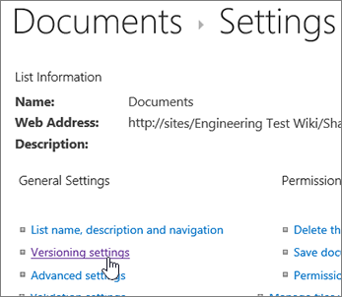

1. In the **Content Approval** section, select **Yes** in answer to the **Require content approval for submitted items?** In the **Document Version History** section, specify whether you want SharePoint to create versions when a file is edited. You can also choose to limit the number of versions that are retained.
2. In the **Draft Item Security** section, determine which users can see draft items in the document library.

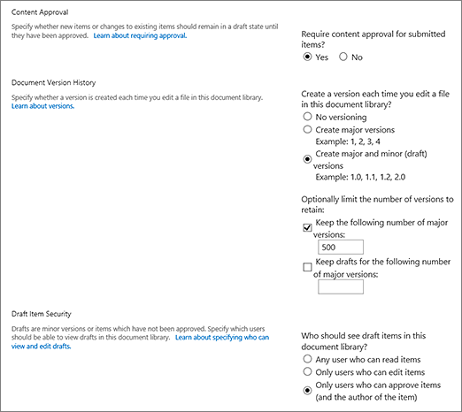

**Tip:**  If you require content approval for a list or library that already contains items, all of the items in the library are marked Approved.

1. You can choose any of the following:
   * Users who can read items in the list
   * Only users who can edit items in the list
   * Only users who can approve items in the list, and the item author
2. Click **OK**.

**What if I don’t care about the order?**

1. Click the ellipses (...) next to the item you want to approve.
2. Click Advanced.
3. Click Approve/Reject. If Approve/Reject doesn't appear, click Advanced, and then click Approve/Reject. If the option doesn't appear at all, versioning may not be enabled, or you may not have permissions to approve a document.
4. Click Approved or Rejected under approval status. Optionally you can add comments in the comment section.
5. Click OK.

**How do I ensure I approve all changes to a document in my library?**

1. Navigate to the library or list where the Pending item or file is located.

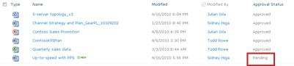

1. Hover over the item, click the arrow, and then, in the drop-down box next to the item or file name, select **Approve/Reject**.

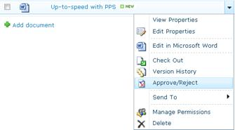

1. In the **Approval Status** section of the dialog box that opens up, select **Approved**.
2. In the **Comment** section, type a comment about why the item was approved. This step is optional, but recommended for history purposes.

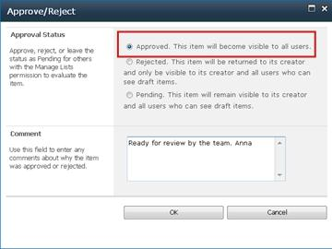

1. Click **OK**. When the **Approve/Reject** dialog box closes, the **Approval Status** of the file is **Approved**.

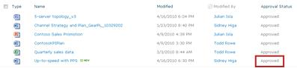

https://sharepointmaven.com/why-you-should-stop-emailing-file-attachments-and-start-sharing-sharepoint-links-instead/

<https://support.office.com/en-us/article/what-is-a-document-library-3b5976dd-65cf-4c9e-bf5a-713c10ca2872>

<https://www.uvic.ca/systems/assets/docs/pdfs/web/sharepoint/List_view.pdf>

<https://support.office.com/en-us/article/create-recurring-tasks-88a4d903-38c3-4665-870e-4810b752f2c4>

<https://support.office.com/en-us/article/introduction-to-sharepoint-workflow-07982276-54e8-4e17-8699-5056eff4d9e3>

<https://www.itprotoday.com/microsoft-sharepoint/5-sharepoint-2013-out-box-workflows>

<https://support.office.com/en-us/article/approve-or-reject-items-or-files-in-a-site-list-or-library-d5931756-5315-4c4a-b89f-18947b6f7305>